St. John’s Public Cemetery

Cemetery Rates

**2878 St. John’s Drive**

**Jordan, Ontario, L0R 1S0**

**Cemetery Board License # 3288266**

**Cemetery License # CM - 02567**

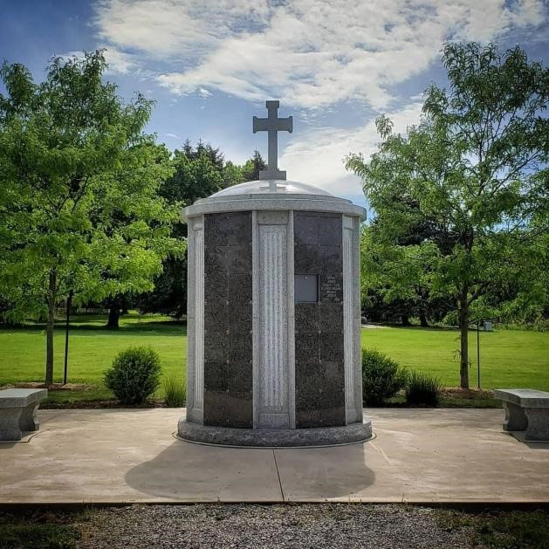

**Effective June 1, 2025**

**Under the authority of**

**The Funeral, Burial and Cremation Services Act SO 2002 Chapter 33**

**In-acted July 1, 2012 by**

**Ontario Regulation 30/11**

# Right to Interment Full Casket Lot

Section A Single Lot for Coffin Burial……………………………………………………………………$ 2,500.00

Section A Double Depth……………………………………………………………………………$4,000.00

Section B Single Lot for Coffin Burial……………………………………………………………………$ 4,000.00

Section B Double Depth……………………………………………………………………………$7,000.00

Section C Single Lot for Coffin Burial……………………………………………………………………$ 2,500.00

Section C Double Depth……………………………………………………………………………$4,000.00

Section K Single Lot for Coffin Burial……………………………………………………………………$ 2,500.00

Section K Double Depth……………………………………………………………………………$4,000.00

Section L Single Lot for Coffin Burial……………………………………………………………………$ 2,500.00

Section L Double Depth……………………………………………………………………….……$4,000.00

Section N Single Lot for Coffin Burial (Natural Burial Ground) ..……………………………$2,500.00

Section N Double Depth……………………………………………………………………………$4,000.00

* Under Section Nine Sub Section 1 (a) of St. John’s Public Cemetery By-Law the Cemetery shall place **40 % or $290.00** of the sale price in the Care and Maintenance Fund for any lot 24 square feet or greater.
* A single lot may have one coffin burial plus a cremated remain or two cremated remains with no coffin burial.
* A request for more than two cremated human remains requires further payment using Section D rates.
* All lots in Section A, B, C, K and L allow for upright markers.
* **Section N (Natural Burial Section) allows for flat markers only**. The Master Monument provided by the Cemetery shall be used and inscribed at lot owner’s cost.
* Section N shall follow all points listed in Section 24 of St. John’s Public Cemetery.
* There are opening and closing fees at time of need.

# Right to Interment Human Cremated Remains (Ground Burial)

Sections D + Pet and Family Section One - Cremated Remains Only………………………………………………............................................................................. $600.00

* Under Section Nine Sub Section 1 (b) of St. John’s Public Cemetery By-Law the Cemetery shall place **40 % or $175.00** of the sale price in the Care and Maintenance Fund for any lot under 24 square feet.
* **Sections D + Pet Section One** allows for cremation interment only.
* Only flat markers are allowed and shall not exceed the footprint of the Lot.
* There are two cremated human remains allowed in each Lot.
* Pet remains are allowed in Pet Section One. (West)
* Lot size is 1.5 feet X 1.5 feet.
* There are opening and closing fees at time of need.

**Rights to Human and Pet Cremated Remains (Ground Burial)**

**Pet Section Two (East)**

* Under Section Nine Sub Section 1 (b) of St. John’s Public Cemetery By-Law the Cemetery shall place **40% or $175.00** of the sale price in the Care and Maintenance Fund for any Lot under 24 square feet.
* Only flat markers are allowed and shall not exceed the footprint of the Lot.
* Pet and Human cremains are allowed to be interred together in Pet Section Two.
* Lot size is 2.0 feet X 2.0 Feet.
* There are opening and closing fees at time of need.
* Cremated Remains Only …………………………………………………………………………….. $1,200.00

# Right to Scatter Human + Pet Cremated Remains

Scattering of cremated human remains on St. John’s Public Cemetery Scattering Grounds

With Inscription………………………………………………………………………………………..………….… $ 500.00

Rights to inscription only or Scatter only ……………………………….……………………..………… $ 250.00

* Under Section Nine Sub Section 1 (f) of St. St. John’s Public Cemetery By-Law the Cemetery shall place **15 % or $30.00** which ever is greater, in the Care and Maintenance Fund.
* There are no Cemetery fees for the scattering.
* The Rights holder shall pay for the inscription on the master monument.
* Independent memorials are not allowed. Rights may be re-sold. The remains are not retrievable and shall only take place within the footprint of the Scattering Grounds.

# Inurnment of Human Cremated Remains (Columbarium)

***“I Am The Vine”*** One Niche…………….…………………………………………………………………………$2,500.00

***Sunset*** Columbarium One Niche..……………………………………………………………………….…….$3,000.00

***Nelson*** Cartesian Columbarium ……………………………………………………………………………… $3,500.00

***Nelson*** Memorial Plaque…………………………………………………………………………………………. $450.00

***Nelson*** Ossuary Placement……………………………………………………………………………………… $300.00

Ossuary remains are not retrievable.

* Under Section Nine Sun Section 1 (d) of St. John’s Public Cemetery By-Law the Cemetery shall place **15 % or $165.00,** which ever is greater, in the Care and Maintenance Fund.
* Each niche in *“I Am the Vine”* will hold two urns provided the urns are of a size that will fit the niche which is the following size (9”X 13”X 10”).
* Each Niche in the Sunset Columbarium may hold two urns provided the urns are of a size that will fit the niche which is the following size (11 ½” X 11 ½” X 16”).
* Each niche in the Nelson Columbarium may hold two urns provided urns are of a size that will fit the niche which is the following size (12” X 12”X 16“)
* *“I Am the Vine”* niche may be re-sold provided there has not been an inscription.
* Sunset and Nelson niches may be re-sold; if faceplate has been inscribed, it shall be replaced at the niche holder’s cost.
* All lettering shall be the **VERMARCO font**.
* All remains are retrievable **EXCEPT from the Nelson Ossuary**
* There are opening and closing fees at time of need.

**Columbarium Inscription Fees**

* “I am the Vine”…………………………………………………………………………………………………. At cost
* Sunset ………………………………………………………………………………………………………………. At cost
* Nelson Niche Frontal ……………………………………………………………………………………….. $1,200.00

This frontal shall be wreath, vase ends, full dates, two names.

* Nelson Memorial …………………………………………………………………………………………….. $500.00

# Open and Closing Fees

* Full Lot Interment……………………………………………………………………………………. $ 1,500.00
* Full Lot Section B ……………………………………………………………………………………. $2,000.00
* Double Depth Interment………………………………………………………………………… $ 1,700.00
* Cremation Ground Interment………………………………………………………………….. $400.00
* Cremation Columbarium Inurnment……………………………………………………….… $200.00

# Storage of Cremated Remains

* The temporary storage of cremated remains …………………………………………………………… $350.00
* One year maximum storage.

# Flat Marker Setting

* If the Cemetery is required to set a flat marker ……………………………………………………….. $300.00
* St. John’s Public Cemetery does not pour foundations nor set upright monuments.
* The Cemetery does not charge for locate.

# Disinterment

* One Coffin Disinterment………………………………………………………..………………… $3,000.00
* Cremation Ground Disinterment……………………………………………………………… $600.00
* Cremation Columbarium Disinterment…………………………………………..…………… $200.00

# Additional Fees

* Transfer of any Interment Rights…………………………………………………..……………… $400.00
* First copy of Price List……………………………………………………………………………………. N/C
* Additional Copies of Price List………………………………………………………………… $10.00 each
* First Copy of By-Law……………………………………………………………………………………… N/C
* Additional Copies of By-Law……………………………………………………………………… $ 35.00 each
* BAO License Fees …………………………………………………………………………………….. $30.00/Lot

**Monument Contribution to Care and Maintenance**

* Flat marker measuring less than 173 square inches …………………………………………. 0
* Flat marker measuring at least 173 square inchers ………………………………………… $100.00
* Upright monument 4 feet or less in height and length …………………………………… $200.00
* Upright monument more than 4 feet in height and length ……………………………. $400.00

**Pre 1955 Sales**

* In accordance with the Funeral, Burial and Cremation Services Act SO 2002 Chapter 33 and Ontario Regulation 30/11 St. John’s Public Cemetery is allowed to charge current Care and Maintenance Fee on any Lot sold prior to 1955.
* This fee is activated when new ownership of the Rights to Interment takes place.
* These fees may be charged using the current St. John’s Public Cemetery price list and the Bereavement Authority of Ontario authorized per centage contribution.

**Other Services**

* Hearth Room Rental – Contact Diane Netherway – stjohnsjordanoffice@gmail.com
* Great Hall Rental -Contact Diane Netherway – [stjohnsjordanoffice@gmail.com](mailto:stjohnsjordanoffice@gmail.com)
* If you would like an Anglican Service in the Historic Church – Contact The Rector – [stjohnsjordanrector@gmail.com](mailto:stjohnsjordanrector@gmail.com)
* Pastoral Care – Including counsel, graveside committal and Church service.

Contact Rev. Pam Guyatt – [stjohnsjordarector@gmail.com](mailto:stjohnsjordarector@gmail.com)

**This Price List was reviewed and passed by the St. John’s Public Cemetery Board on May 21, 2025.**

Brian G. Culp

Superintendent,

St. John’s Public Cemetery,

2878 St. John’s Drive,

JORDAN, Ontario.

L0R 1S0

905-562-5945

905-641-5945 © Preferred